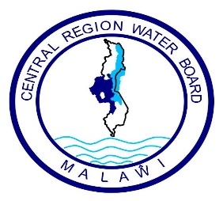

Central Region Water Board
Request for Quotations (RFQ) for FURNITURE

- The Central Region Water Board is inviting eligible bidders to Supply Furniture through Request for quotations.

- Interested eligible Suppliers must be registered with M.R.A, P.P.D.A and M.S.M.E and will be required to complete a set of Request for Quotations which can be downloaded from Central Region Water Board website

- Sealed Bids must be delivered and deposited at CRWB head office on or before 14.00 hours on Friday 30th August 2024 clearly marked with Request for Quotation for Furniture as indicated above.

- Bids will be opened at Central Region Water Board on Friday 30th August 2024 at 14.00 hours’ local time. Late bids shall be rejected.

- Central Region Water Board reserves the right to reject any or all bids and is not bound to accept the lowest or any other bidder.

- Addresses for:

- Clarifications:

Attention: Mr. Time Nyalapa – Acting Procurement and Disposal Manager
Central Region Water Board Offices
Area 4, Murray Road
Opposite Immigration Offices
Private Bag 59
Lilongwe
Malawi
Phone No: 01 758 044 / 045/ 046
Cellphones: 0888 903 621/ 0999 203 621
Email: crwb@crwb.org.mw / tnyalapa@crwb.org.mw

- Submissions

Attention: Engineer John Makwenda – Chief Executive Officer
Central Region Water Board Offices
Area 4, Murray Road
Opposite Immigration Offices
Private Bag 59
Lilongwe
Malawi
Phone No: 01 758 044 / 045/ 046
Cellphones: 0881 707 535 / 0996 707 535
Email: crwb@crwb.org.mw / jmakwenda@crwb.org.mw

